Town of Paris

Email Update

October 21, 2016

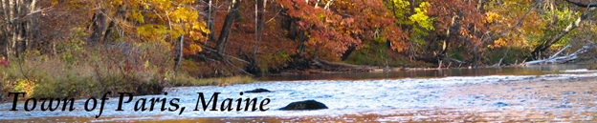

cid:image002.gif@01D0947B.6F5BA670

Great work to Paris Fire Department on your open house event! (Thank you Chad Boulet Hunter for the photo!)

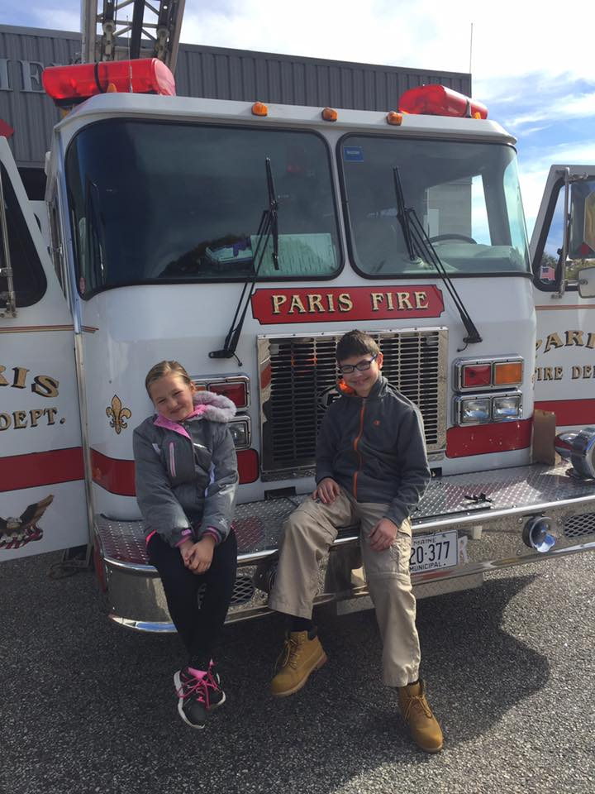

cid:image002.gif@01D0947B.6F5BA670

Shared from Oxford Hills Middle School of South Paris: Students from North and South Campus carved over 200 pumpkins for McLaughlin Gardens annual Jack O' Lantern Spectacular!

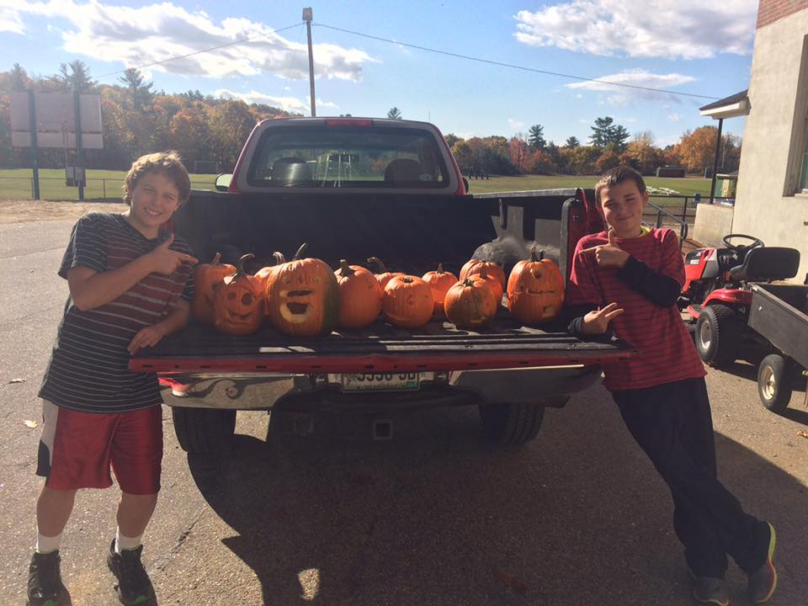

cid:image002.gif@01D0947B.6F5BA670

Daylight Savings Time ends on Sunday, Nov. 6, when you will set your clocks back one hour. It is also a good time to check the batteries in all your detectors. And by the way, did you get your house numbers posted close to the road or on your house so emergency responders can find you quickly? There are still some nice days left to get this done before winter sets in!

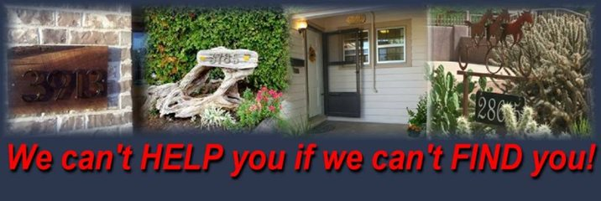

cid:image002.gif@01D0947B.6F5BA670

The Re Opening of McDonald's will be Friday, October 28 at 5 AM!

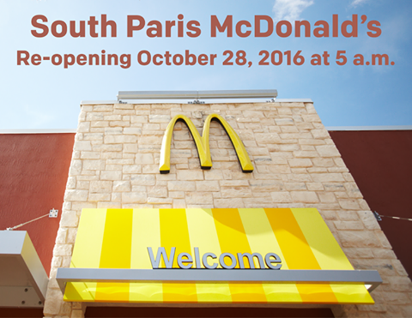

cid:image002.gif@01D0947B.6F5BA670

Shared from Community Concepts: Thinking about buying a home but don't know where to start? Community Concepts offers homebuyer education classes that cover everything from money management and qualifying for a mortgage to shopping for a home, closing, and life as a homeowner. Sign up for our November class today! <https://www.eventbrite.com/e/community-concepts-homeworks-homebuyer-education-november-7-9-14-16-registration-27198767245>

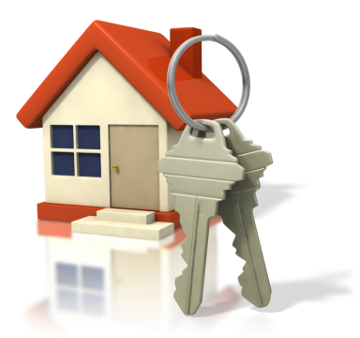

cid:image002.gif@01D0947B.6F5BA670

Oxford Hills Music, Art, and Drama Boosters present our Second Annual Princess Brunch! Come share refreshments, music, face painting, dancing, and get your picture taken with a fairytale princess! Cinderella, Belle, Snow White and more! No need to travel to make your dreams come true. See fairy tales come to life here in Oxford Hills and support the Arts in our schools. Tickets are only $10 per person. Advance Tickets ONLY. Tickets are available at Happi Chicks Bake Shop and Hair Plus or call 207-583-6379. Fairytales Come to Life! Come share refreshments, music, face painting, dancing, and get your picture taken with a fairytale princess! Cinderella, Belle, Snow White, and more! No need to travel to make your dreams come true. See fairy tales come to life right here in Oxford Hills and support the Arts in our schools. New surprises and more fun! Saturday November 12th, 10am to noon at OHCHS cafeteria.

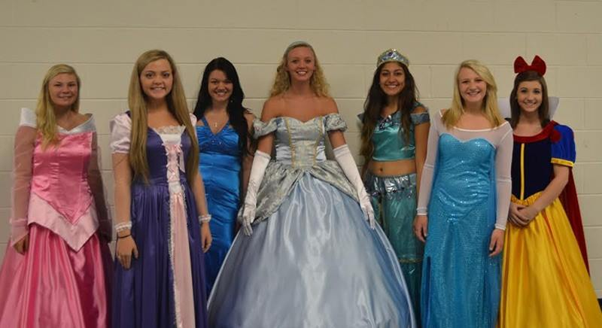

cid:image002.gif@01D0947B.6F5BA670

The Oxford Hills Chamber is hosting the Business & Community Expo on Saturday, October 22 in the gym at Oxford Hills Comprehensive High School. We're bringing some new and exciting elements into this event to attract a more diverse group of attendees. There will be an inflatable from Lil' Leapin' Lizards for the kids as well as a performance by the Celebration Barn Theater group. Mt. Abram will do a presentation about their solar projects and the all-student Aspire Higher Racing Team will talk about the race car they have built and raced at Oxford Plains Speedway. The race car will also be on display. In addition to all of these activities, we will also have our annual Chili-Chowder contest. You can register online now for this event or contact Jennifer in the Chamber for more information: (207) 743-2281.



cid:image002.gif@01D0947B.6F5BA670

Join the Norway-Paris Kiwanis Club for a Masquerade Ball on Saturday, October 29. You can choose your favorite masquerade attire and enjoy a musical review by OHMPAA along with a four-course dinner. This event will be held at Granite Ridge Estate & Barn. All guests will be chauffeured from Oxford Hills Comprehensive High School at 4:45 PM to Granite Ridge. Tickets are $60 per person which includes music, meal, tax and gratuity. Cash bar is available as well as live and silent auction items. For tickets and more information contact Tina Croteau at 207.393.3612 or Mary Anna Palmer at 207.539.4800.



cid:image002.gif@01D0947B.6F5BA670

Moore Park Halloween Party! It's time for our Second Annual Halloween Celebration. Back by popular demand, 2016 More at Moore Park Halloween event. We are always looking for volunteers and donations. Thanks to all the volunteers, contributors and attendees who came out last year to make this such a special event! This is a free event to celebrate our community and have some fun! Friday, October 28 at 3:30 PM!

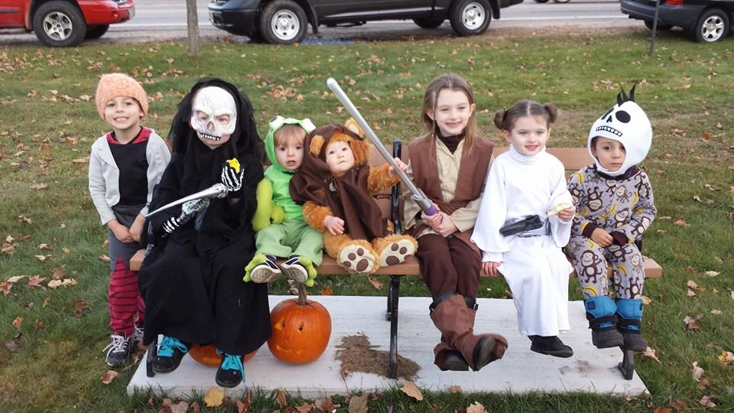

cid:image002.gif@01D0947B.6F5BA670

Thank you to Susan Marie for this lovely shot of Moore Park in South Paris, taken earlier this week!

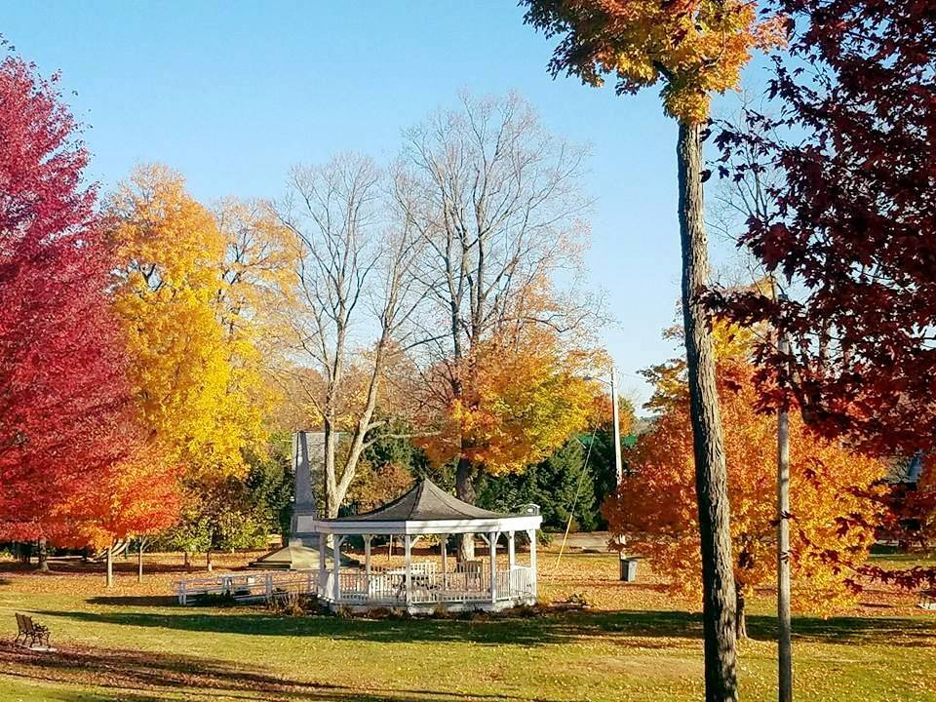

cid:image002.gif@01D0947B.6F5BA670