Town of Paris

Email Update

September 16, 2016



cid:image002.gif@01D0947B.6F5BA670

Town of Paris Highway Department is seeking a Helper/Laborer. Candidates must be able to perform heavy physical labor and work as a team member. Duties include, but not limited to:

* Cutting brush
* Patching Roads
* Sweeping Street
* Installation of culverts
* Plowing snow
* Sanding Roads

Applicant must have a CDL license in good standing, minimum of 2 years’ experience, and high school diploma or equivalent. Public works maintenance and equipment operation experience desirable, but will train the right person. Candidate must be willing to work in all weather conditions and overtime as required. The Town of Paris offers a comprehensive benefit package which includes:

* Competitive salary package
* Paid medical, dental
* Vacation and sick leave
* Retirement plans
* Paid holidays

Resumes should be marked “Laborer” Town of Paris, 33 Market Square, South Paris, Maine 04281 or electronically to townclerk@parismaine.org. Resumes and Cover Letter will be accepted until October 7, 2016 or until a qualified candidate is found. Paris is an EOE



cid:image002.gif@01D0947B.6F5BA670

Oxford Hills SCORE is pleased to offer QuickBooks Basics - The Expanded Version for small businesses in our community and beyond. This 4 part program will be starting October 5th. Seating will be limited so reserve yours now! <http://events.r20.constantcontact.com/register/event?oeidk=a07ed5399c2add93fe3&llr=wmdhgxcab>



cid:image002.gif@01D0947B.6F5BA670

Shared from McLaughlin Garden of Paris: Calling all Carvers! We're starting to harvest and gather pumpkins for our Jack O'Lantern Spectacular. We're looking for carvers of all ages to come to our "Carving Room" on the second floor of the McLaughlin Home to carve pumpkins on Wednesday, October 19 and Thursday, October 20. This year our themes are dinosaurs and emojis. If you are interested, please contact us via email at mclgardn@megalink.net. Join in the fun and help to make the Jack O'Lantern Spectacular extra special (this year the event will be on Friday October 21 and Saturday October 22).

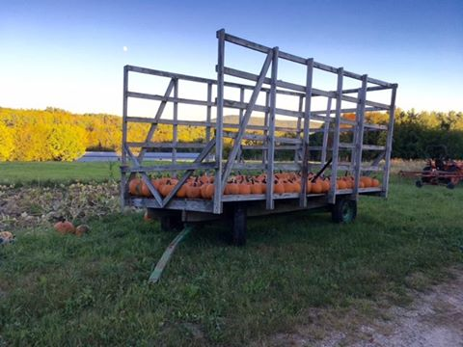

cid:image002.gif@01D0947B.6F5BA670

Shared from Parris Wool Works: Join us once again for the Paris Hill Hook-In! Space is limited to 60 attendees so please register in advance and invite your friends to do so also!

Saturday, November 5th, 2016, 10 a.m. - 4:00 p.m. at the First Baptist Church of Paris, Center of the Village Green, Paris Hill Road, Paris, Maine. Registration Deadline: October 29th, 2016

* Ticket Price: $28.00
* Breakfast & Lunch included
* Informal Rug Show: Bring your favorites to share! As many as you like!
* Vendors & Door Prizes
* Ring the Early 19th Century Paul Revere Foundry Church Bell!

WE WILL BE DRAWING THE WINNING TICKET FOR OUR RAFFLE RUG!!! FMI and Registration Form contact: Beth Miller, 207-890-8490 or [parrishousewoolworks@gmail.com](mailto:parrishousewoolworks@gmail.com)

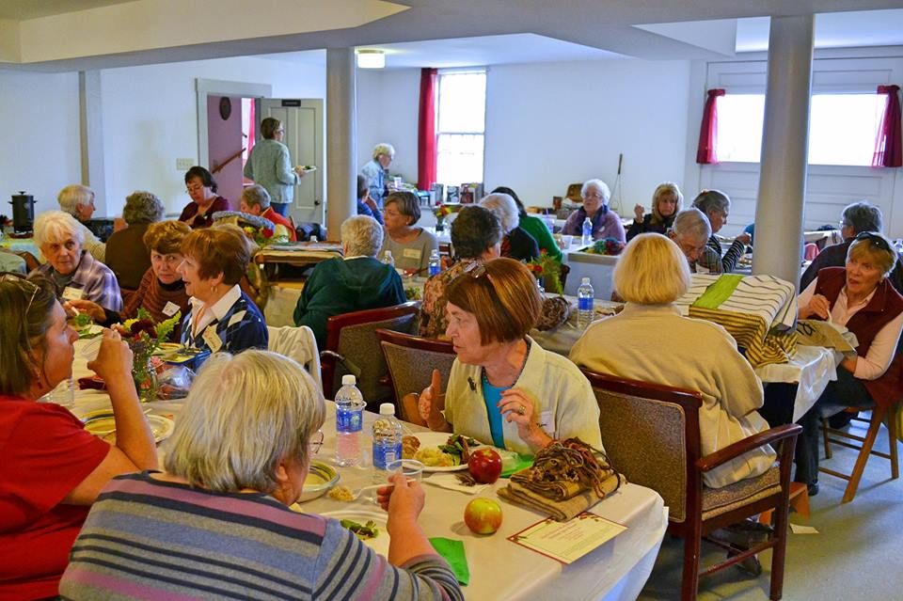

cid:image002.gif@01D0947B.6F5BA670

Chicken Pie Supper - Sponsored by AMVETS, Post # 777 at the VFW Post #9787, 58 Lower Main Street, South Paris. Supper on September 24th from 4:30PM to 6PM. Adults $8.00 and children under 10- $4.00. Come enjoy a delicious meal and some companionship with your neighbors!



cid:image002.gif@01D0947B.6F5BA670



cid:image002.gif@01D0947B.6F5BA670

The Town is seeking a CEO/Addressing Officer to work 40 hours per week and attend Planning Board Meetings. This is a technical and administrative position responsible for enforcement of all municipal codes, ordinances and other applicable federal and state ordinances, and for E911 coordination. Applicant must be if not already, within twelve (12) months, must have successfully obtained State of Maine Certification for a Code Enforcement Officer, as well as State of Maine certification to be a qualified food inspector/sanitarian, and state certification as a local Plumbing Inspector. Must hold a valid Class C State of Maine Motor Vehicle Operator’s License. Must have and maintain a good driving record as a condition employment. Please send cover letter, resume, and professional references to Town of Paris, Attn: Town Manager, Town of Paris, 33 Market Square, South Paris, ME 04281 or e-mail: manager@parismaine.org. Applications will be accepted until a qualified applicant is found.



cid:image002.gif@01D0947B.6F5BA670

The Park Street Garden in South Paris, and Tuesday Night Garden in Rumford have now completed 8 weekly distributions of produce grown in the GGHC gardens and grown and donated by local businesses and individuals. Here are the pounds of food distributed so far:

Week 1 - 800 lbs;

Week 2 - 900 lbs;

Week 3 - 1000 lbs;

Weeks 5 through 8 have averaged 1350 lbs each!

Special thanks for the weekly donations received from Pietree Orchard in Sweden, and Wildfire Fellowship Farm in Buckfield. Cooper Farms Stand in West Paris has also donated produce and provided both gardens with purchased supplemental produce and fruit. Our clients are always very happy when Cooper's corn makes its appearance! Thanks, also, to the First Congregational Church of South Paris for the use of their facility and kitchen for the cooking demonstrations.

Our distributions in South Paris to date have provided fresh produce for 60 to 74 households, feeding about 124 to 145 individuals each week!

Later this month we hope to glean apples at Pietree Orchard. We also hope to arrange other gleaning opportunities for squash, potatoes, etc. If you know of farms that would allow gleaning, please share the information with us.

Please keep spreading the word about GGHC and keep your donations coming. We expect to continue weekly distributions into early October.

Thank you all for your support!

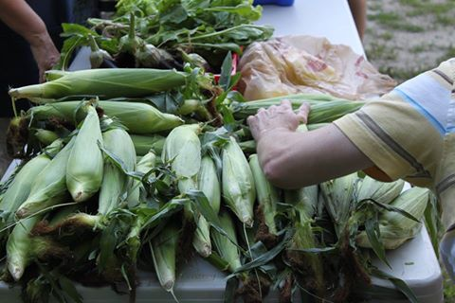

cid:image002.gif@01D0947B.6F5BA670

Need help getting your kids up and out in the morning? Having trouble with sibling rivalry, whining, or getting kids to start their chores? Community Concepts is offering a workshop for parents and caretakers of children ages 2-12 beginning September 15. Call Alyson Holland at (207) 739-6549 to reserve your space today!



cid:image002.gif@01D0947B.6F5BA670

Jones Dance Band playing old fashioned dance music at the Legion Hall on Church Street in South Paris! September 3, 10, 17 and 24th. Dances from 7PM to 10PM. Adults $5.00. Come and have a great time!



cid:image002.gif@01D0947B.6F5BA670